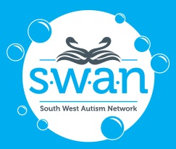 | South West Autism Network Inc  Annual General Meeting

Board Nomination Form

I, ____________________________________________________________________________

nominate for election to the South West Autism Network Inc (SWAN) Board at the Annual General Meeting, to be held from 6.00pm Tuesday 7th December 2021 via Zoom online.

Full Name:
Occupation:
Address
Telephone:
Email:
Board Position I am nominating for:  (please circle) |  | President | Vice President | Secretary
 |  | Treasurer | General Board Member | Youth Representative
The skills and knowledge that I will bring to the Board if elected are:
Signature |  |  |  | Date:
Endorsed by registered SWAN Member:
Full Name:
Address:
Telephone:
Email:
Signature |  |  |  | Date:

Please return your completed nomination form to:

South West Autism Network Inc
Email: info@swanautism.org.au
Mail: South West Autism Network
PO Box 1739
Busselton WA 6280
Phone: 0499 819 038

* If you are unable to return your completed form prior to the AGM, please contact SWAN to advise that you will be nominating. *

