Yallingup Maze SWAN Xmas Party

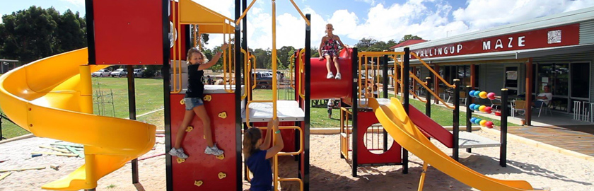
Ho! Ho! Ho!

When: Sunday 28th November 2021
Time: 10.30am to 3.00pm
12.00pm – Sausage Sizzle lunch
Venue: Yallingup Maze
3059 Caves Rd, Yallingup WA 6282
Cost: $6.00 per person entering the maze
Please bring a wrapped gift for each of your children for Santa to give out (clearly labelled with their name, max value $10)

A FUN day out for the whole family at the amazing Yallingup Maze. Santa will be in attendance, and the venue includes a bouncy castle, playground, picnic area, café, large air-conditioned activity room filled with puzzles and games to play and of course, the maze! SWAN are providing face painting, high ropes course, obstacle bouncy castle, sensory-break area, sausage sizzle lunch, fruit platters, juice, water and a visit from Bunbury Batman. Each family will receive a gift bag to take home at the end of the day. The Yallingup Maze have a café with games & puzzles shop on-site for other purchases if desired.

Please complete the attached registration form and return to SWAN by:
Tuesday 23rd November 2021

Volunteers are welcome and greatly appreciated! Please contact us.

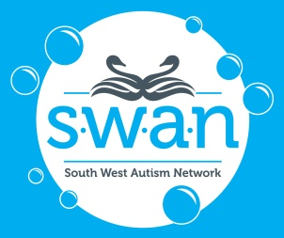 | Email:  Postal:  Phone: | info@swanautism.org.au  PO Box 1739, Busselton WA 6280  0499 819 038
Yallingup Maze SWAN Xmas Party

10.30am to 3.00pm Sunday 28th November 2021

FAMILY REGISTRATION FORM

Names of People attending SWAN Christmas Party at Yallingup Maze (adult ages not required):
Full Name: |  | Age:
Full Name: |  | Age:
Full Name: |  | Age:
Full Name: |  | Age:
Full Name: |  | Age:
Full Name: |  | Age:
Address:
Phone No:
Email:

Emergency Contact Details:
Full Name:
Contact No:

Special Dietary Requirements:

What to do:

- Complete this registration form (including a photo permission form for each child attending) and:
- email to info@swanautism.org.au
- drop into the SWAN Office at
- 6 Pettit Cres, West Busselton WA 6280 (next to Seventh Day Adventist Church), or
- Milligan CLRC, 35 Milligan St, Carey Park WA 6230
- Purchase a gift (maximum value $10.00) for each child in your family for Santa to hand out. Please wrap the presents, and clearly label with your child(ren)’s full name.
- On arrival, advise Yallingup Maze staff that you are with the SWAN group.
- Pay only $6.00 entry for each person who will be entering the maze. SWAN will cover the remaining costs.
- COVID-19: Please check in at the venue using the SafeWA app or sign in, and use the hand sanitizer available.
- IMPORTANT: The Yallingup Maze is an open venue (unfenced) with a dam on the property – parent / guardian supervision is required at all times. The maze itself is fenced, the café & surrounding outdoor area is wheelchair accessible, and a wheelchair accessible toilet is on-site.
- Have a fabulous day!

YES I am able to assist in the running of the SWAN Xmas Party. Please contact:

Signature: |  | Date:

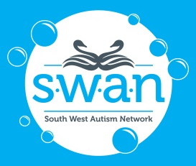 | The privacy and confidentiality of your family will be treated with respect at all times.  No personal information will be released without your prior consent.  PLEASE RETURN COMPLETED FORM TO SWAN BY  TUESDAY 23rd November 2021.  Thank you for your assistance.
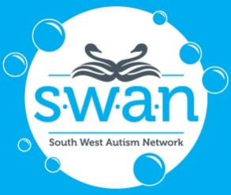 |  | South West Autism Network  Photograph Permission Information for Parents  (TO BE KEPT BY PARENTS)

Dear Parent/Guardian,

At certain times throughout your child’s time spent at SWAN events, participants may have the opportunity to be photographed for our publications, such as the SWAN Newsletter, website, Facebook promotional page, to promote SWAN in local newspapers, and assist in the application for and acquittal of grant funds. Parent or guardian permission is required for the photograph of someone under the age of 18yrs to be used for the above purposes. Please carefully read and complete the Ongoing Permission Form below and return it to the SWAN Office as soon as possible. Please complete one form for each child participating in SWAN events. Thank you for your continued support.

Please detach and return this Permission Form to the SWAN office as soon as possible:

Photograph Permission Form (Ongoing)

I,

give permission for my child

do NOT give permission for my child

to be photographed by staff and volunteers of SWAN in accordance with the terms and conditions listed in the Photo Permission Guidelines which I have read and understood.

give permission for photographs of my child

do NOT give permission for photographs of my child
to be published in printed promotional and educational materials for SWAN without acknowledgment, remuneration or compensation.

give permission for photographs of my child

do NOT give permission for photographs of my child

to be published in online promotional and educational materials for SWAN without acknowledgment, remuneration or compensation.

CHILD’S NAME:

DATE OF BIRTH: / /

Please note that this is an Ongoing Permission Form, for your child’s entire time involved with SWAN programs and services. Please confirm that you understand and agree that if you wish to withdraw this authorisation, it is your responsibility to notify SWAN.

Signature of Parent/Guardian:

Name of Parent/Guardian:

DATE: / /

