SWAN Xmas Party
Bunbury Wildlife Park & Big Swamp Playground

10.30am to 3.00pm Sunday 4th December 2022

FAMILY REGISTRATION FORM

Names of People attending SWAN Family Christmas Party (adult ages not required):
Full Name: |  | Age:
Full Name: |  | Age:
Full Name: |  | Age:
Full Name: |  | Age:
Full Name: |  | Age:
Full Name: |  | Age:
Address:
Phone No:
Email:

Emergency Contact Details:
Full Name:
Contact No:

Special Dietary Requirements/Allergies:

What to do:

- Complete this registration form (including a photo permission form for each child attending) and: email to info@swanautism.org.au

- Purchase a gift (maximum value $10.00) for each child in your family for Santa to hand out. Please wrap the presents, and clearly label with your child(ren)’s full name.

- On arrival, attend the registration tent outside the Wildlife Park entrance, and see SWAN staff to receive your name tags (stickers).

- Name tags will ensure you receive free entrance to the Wildlife Park, as well as free access to the other attractions and sausage sizzle.

- COVID-19: Please use the hand sanitizer available. If you are unwell or have any symptoms, please advise SWAN and do not attend. Thank you.

- Have a fabulous day!

YES I am able to assist in the running of the SWAN Xmas Party. Please contact: ___________

Signature: |  | Date:

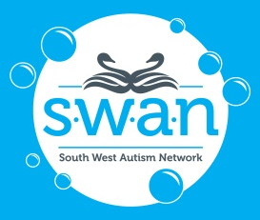 | The privacy and confidentiality of your family will be treated with respect at all times.  No personal information will be released without your prior consent.  PLEASE RETURN COMPLETED FORM TO SWAN BY  TUESDAY 29th November 2022.  Thank you for your assistance.
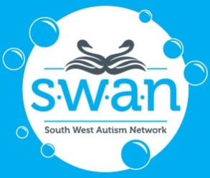 |  | South West Autism Network  Photograph Permission Information for Parents  (TO BE KEPT BY PARENTS)

Dear Parent/Guardian,

At certain times throughout your child’s time spent at SWAN events, participants may have the opportunity to be photographed for our publications, such as the SWAN Newsletter, website, Facebook promotional page, to promote SWAN in local newspapers, and assist in the application for and acquittal of grant funds. Parent or guardian permission is required for the photograph of someone under the age of 18yrs to be used for the above purposes. Please carefully read and complete the Ongoing Permission Form below and return it to the SWAN Office as soon as possible. Please complete one form for each child participating in SWAN events. Thank you for your continued support.

Please detach and return this Permission Form to the SWAN office as soon as possible:

Photograph Permission Form (Ongoing)

I,

give permission for my child

do NOT give permission for my child

to be photographed by staff and volunteers of SWAN in accordance with the terms and conditions listed in the Photo Permission Guidelines which I have read and understood.

give permission for photographs of my child

do NOT give permission for photographs of my child
to be published in printed promotional and educational materials for SWAN without acknowledgment, remuneration or compensation.

give permission for photographs of my child

do NOT give permission for photographs of my child

to be published in online promotional and educational materials for SWAN without acknowledgment, remuneration or compensation.

CHILD’S NAME:

DATE OF BIRTH: / /

Please note that this is an Ongoing Permission Form, for your child’s entire time involved with SWAN programs and services. Please confirm that you understand and agree that if you wish to withdraw this authorisation, it is your responsibility to notify SWAN.

Signature of Parent/Guardian:

Name of Parent/Guardian:

DATE: / /

